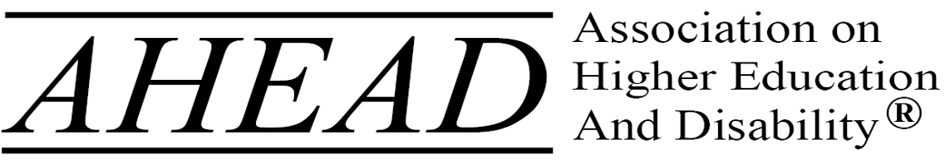

AHEAD is the leading professional membership association for individuals committed to equity for persons with disabilities in higher education.
Since 1977, AHEAD has offered an unparalleled member experience to disability resource professionals, student affairs personnel, ADA coordinators, diversity officers, AT/IT staff, faculty and other instructional personnel, and colleagues who are invested in creating welcoming higher education experiences for disabled individuals. Informed by its diverse membership, AHEAD
- delivers exceptional professional development opportunities through conferences, workshops, webinars, publications, and consultation;
- fosters community and member networking;
- informs members of emerging issues relevant to disability and higher education in the legislative and regulatory spheres; and
- disseminates data, promotes research, and furthers evidence-based practice.
AHEAD boasts a membership of over 4,000, representing all 50 states and over 10 countries. In addition to its direct memberships, AHEAD has formal partnerships with 37 Regional Affiliates and numerous professional organizations. AHEAD members are actively engaged in service provision, consultation and training, and policy development on their campuses and promote accessibility across the field of higher education and beyond.

